A000-Asia-Ghandhara-meditating figure

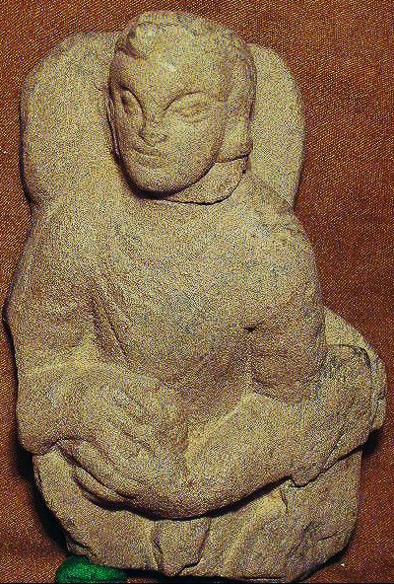 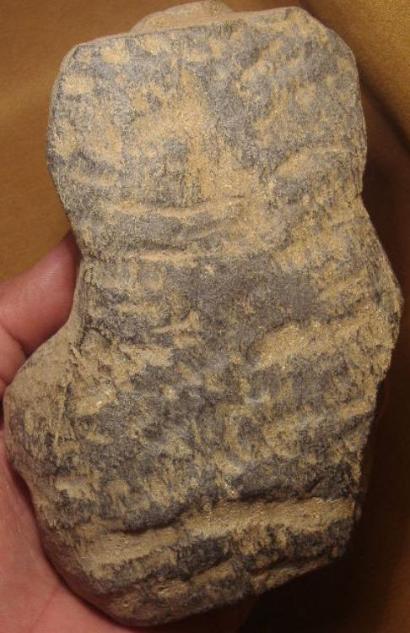

Gray Schist Figure ca.200-300 AD/CE, from the Swat Valley Pakistan.

Sold by [ggalleries](http://myworld.ebay.com/ggalleries) ( [267](http://feedback.ebay.com/ws/eBayISAPI.dll?ViewFeedback&userid=ggalleries) )

### Delivery package 1 of 1

Estimated delivery Monday, Feb 8, 2016 - Friday, Feb 26, 2016

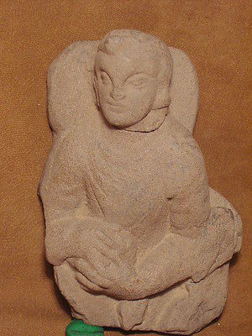

#### [Gandhara/Gandharan Stone FIGURE 200 AD No Reserve](http://www.ebay.com/itm/321980664339)

|  |  |
| --- | --- |
| Item price | $99.99 |
| Quantity | 1 |
| Item number | 321980664339 |
| Shipping $30.00 | Economy Shipping from outside US |